* Error boundary cath the error and display to the ui not break whole application.. display fall back ui

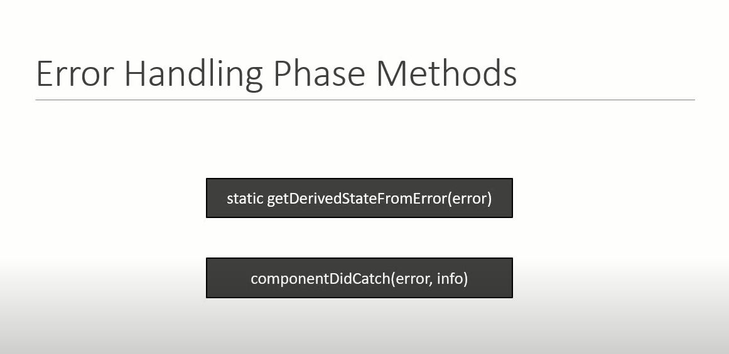

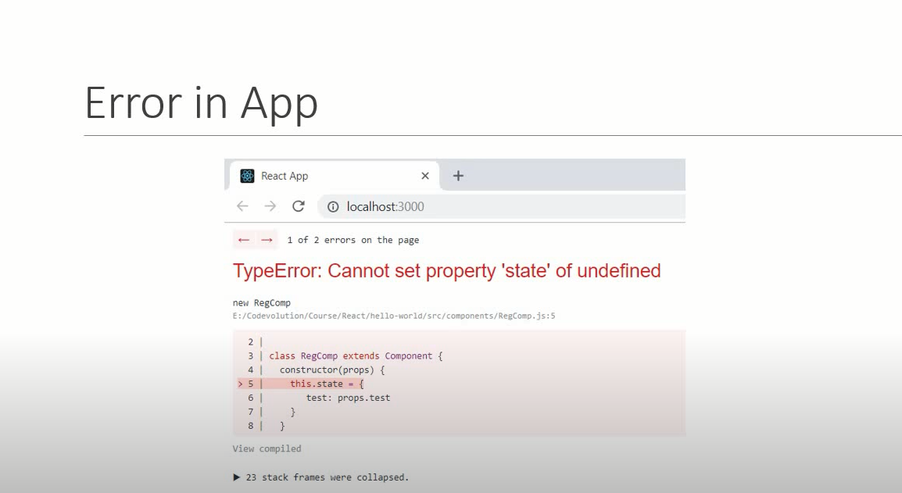

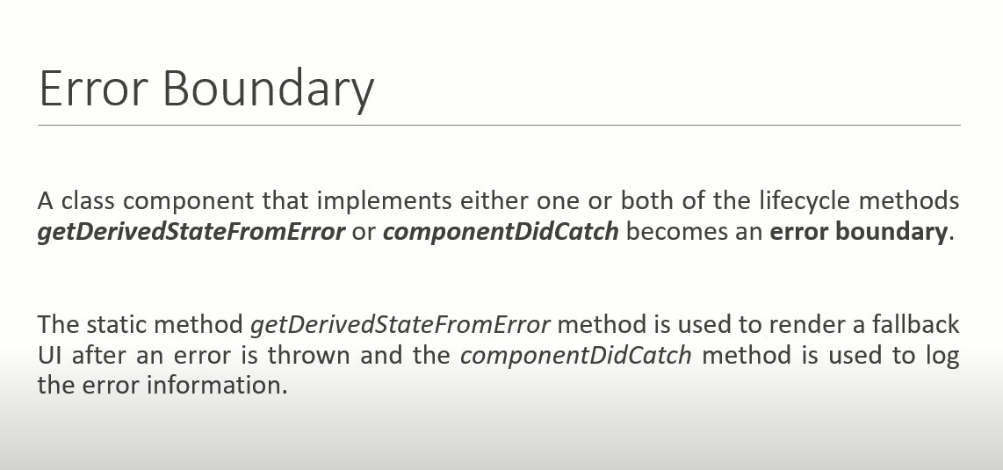

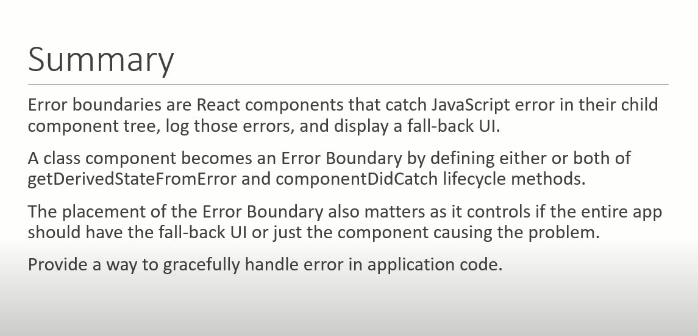

Example :

Create one component we will try to create error

import React from 'react'

function Hero({heroName}) {

if(heroName=== 'Joker'){

    throw new Error('not a hero!')

}

  return (

    <div>

      {heroName}

    </div>

  )

}

export default Hero

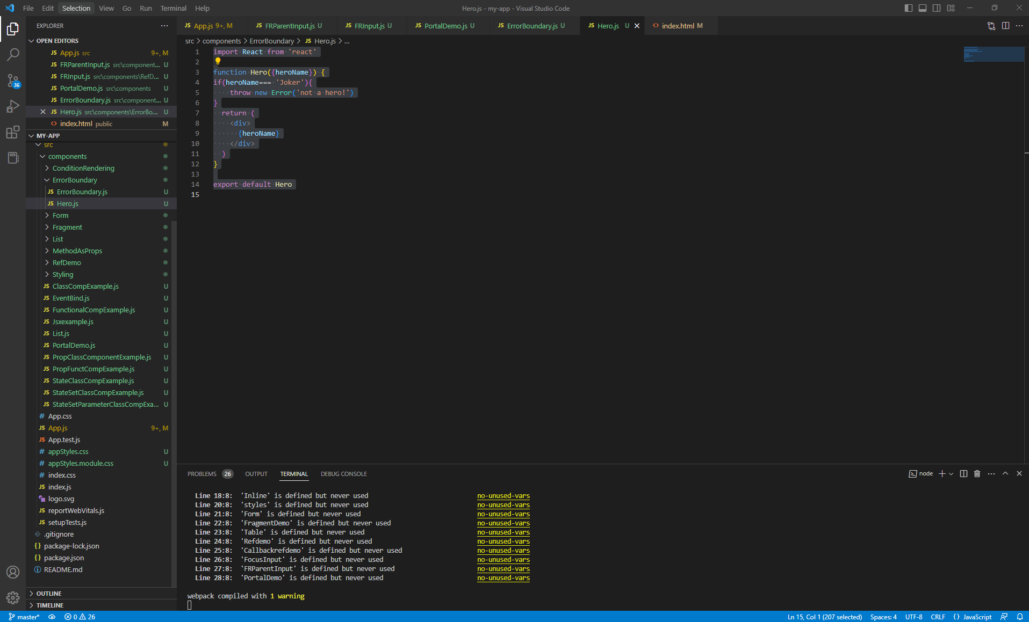

Create component for ErrorBoundary :

import React, { Component } from 'react'

 class ErrorBoundary extends Component {

    constructor(props) {

      super(props)

      this.state = {

         hasError:false

      }

    }

    static getDerivedStateFromError(error){

        return{

            hasError: true

        }

    }

  render() {

      if(this.state.hasError){

        return <h1>Something went wrong !!!</h1>

      }

      return this.props.children

  }

}

export default ErrorBoundary

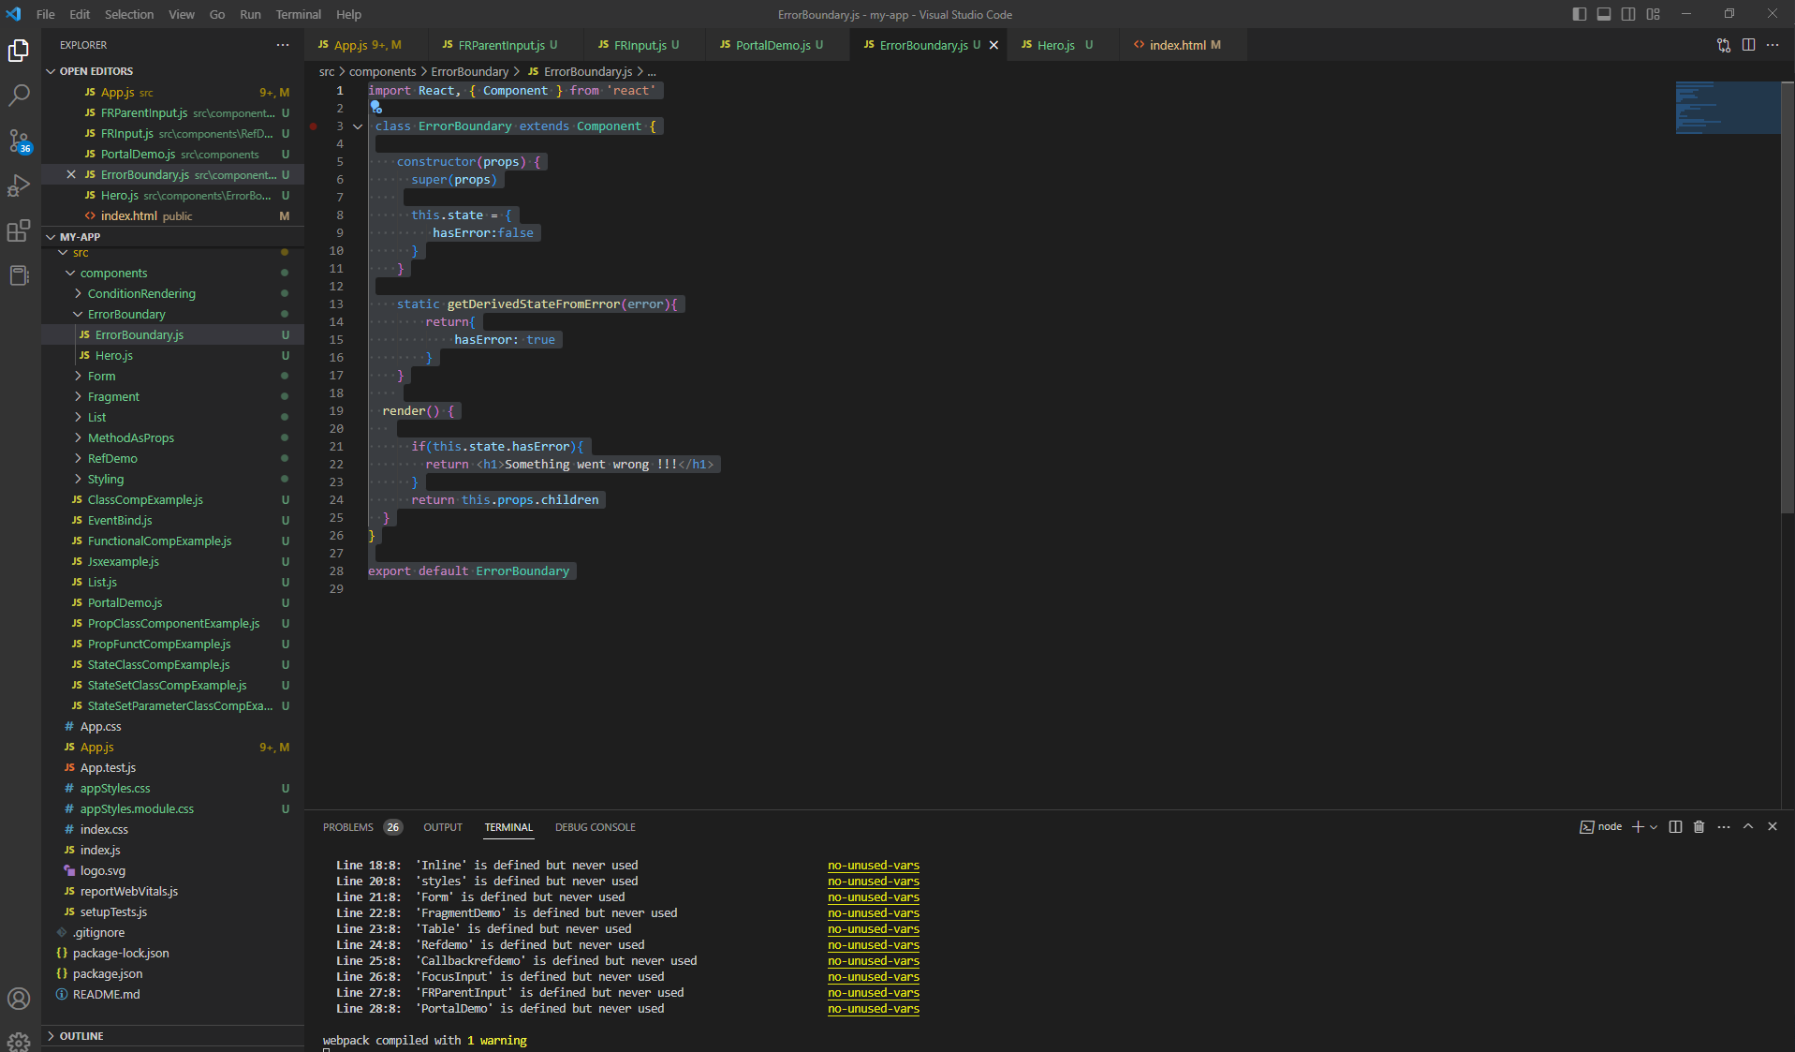

In App.js Call Both Component like ErrorBoundry and hero component

<ErrorBoundary>

<Hero heroName="Batman" />

<Hero heroName="Superman"/>

<Hero heroName="Joker" />

</ErrorBoundary>

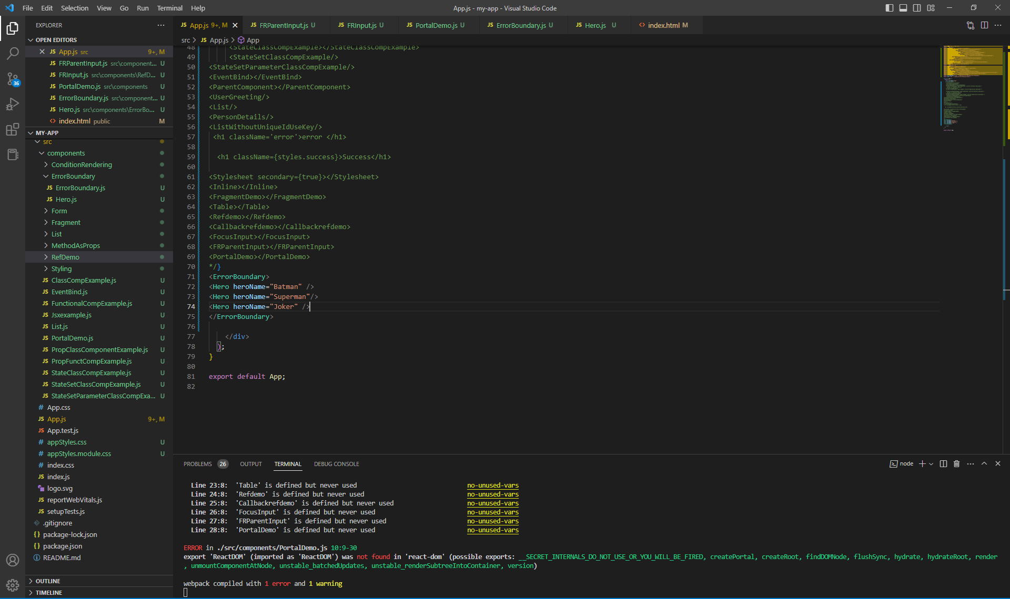

Output >

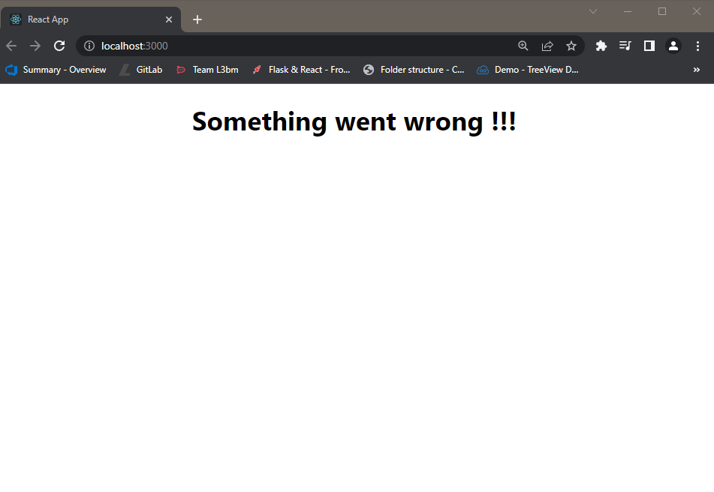

If you are going to comment joker the out put :

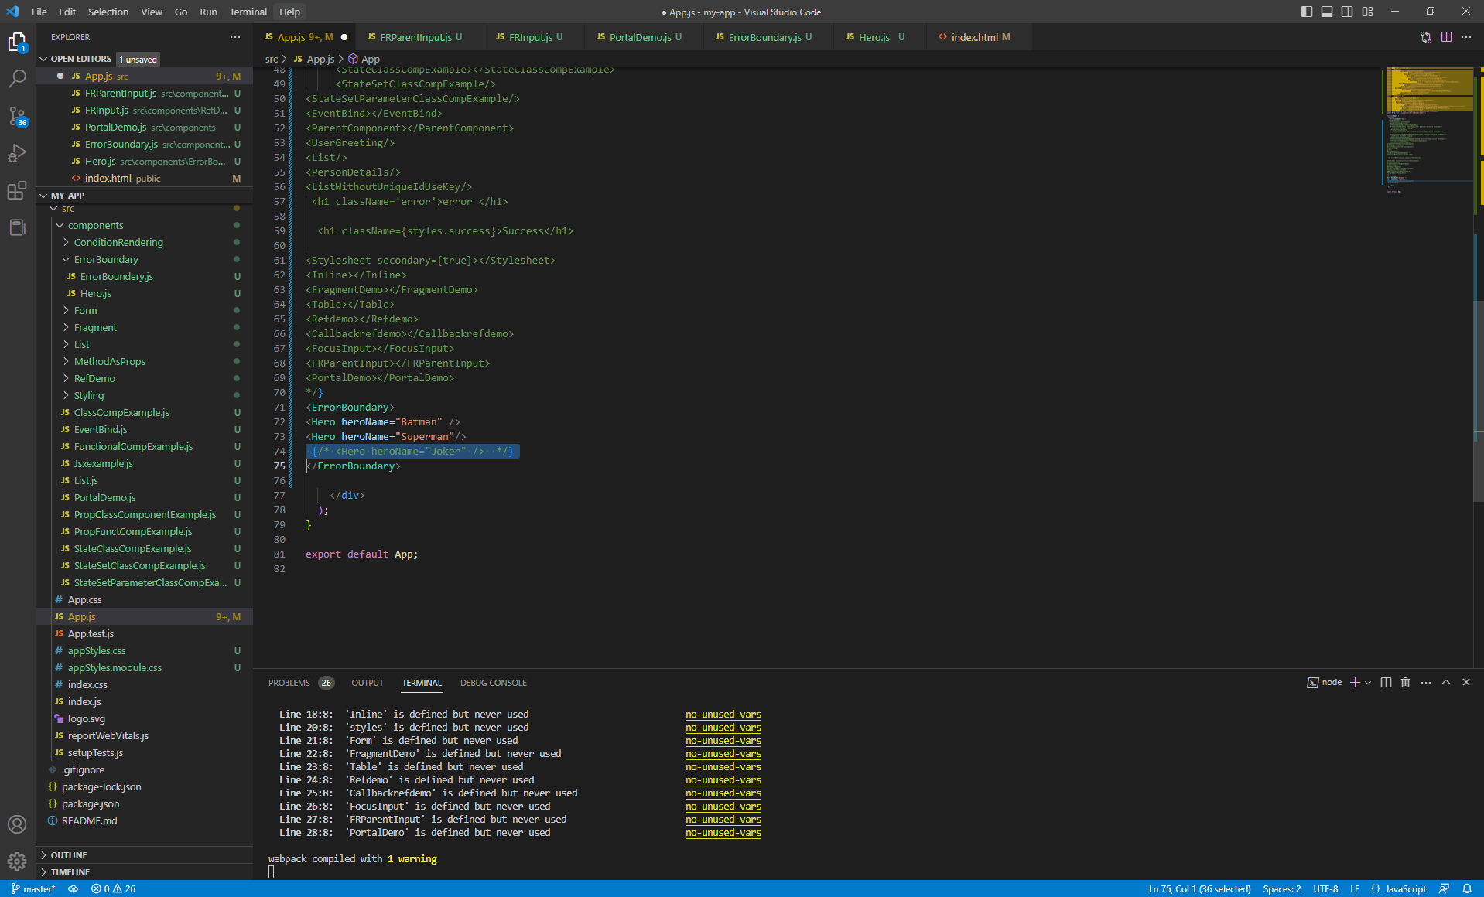

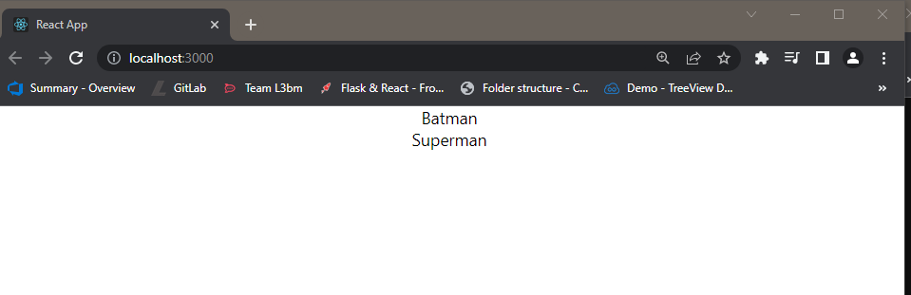

=-===================================================================================

So it is not good idea to show error page for whole so .. we can wrap individual all the element\

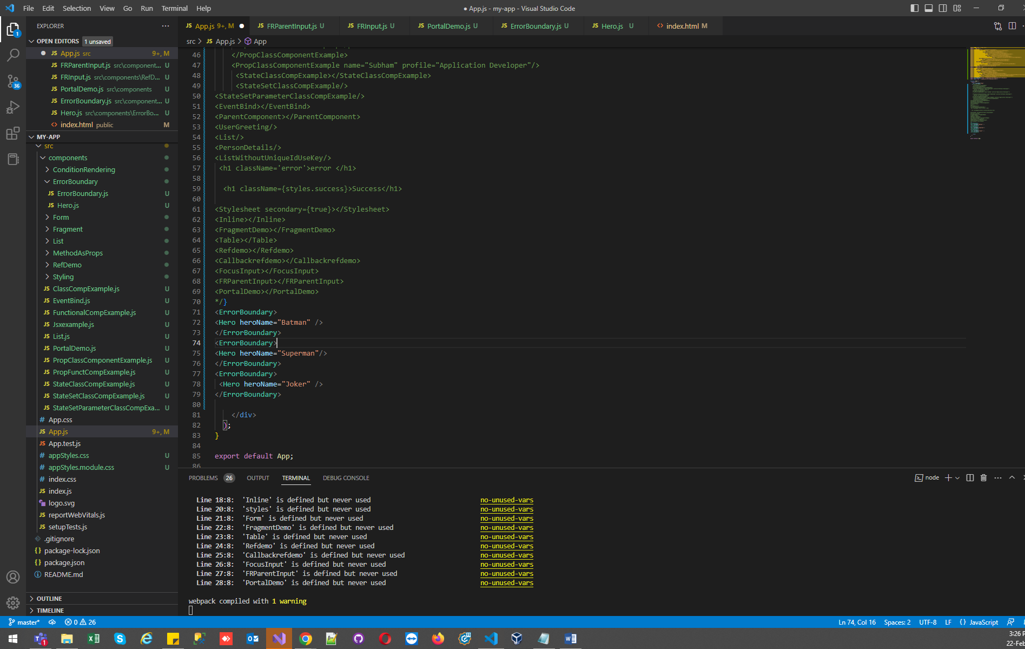

Output :

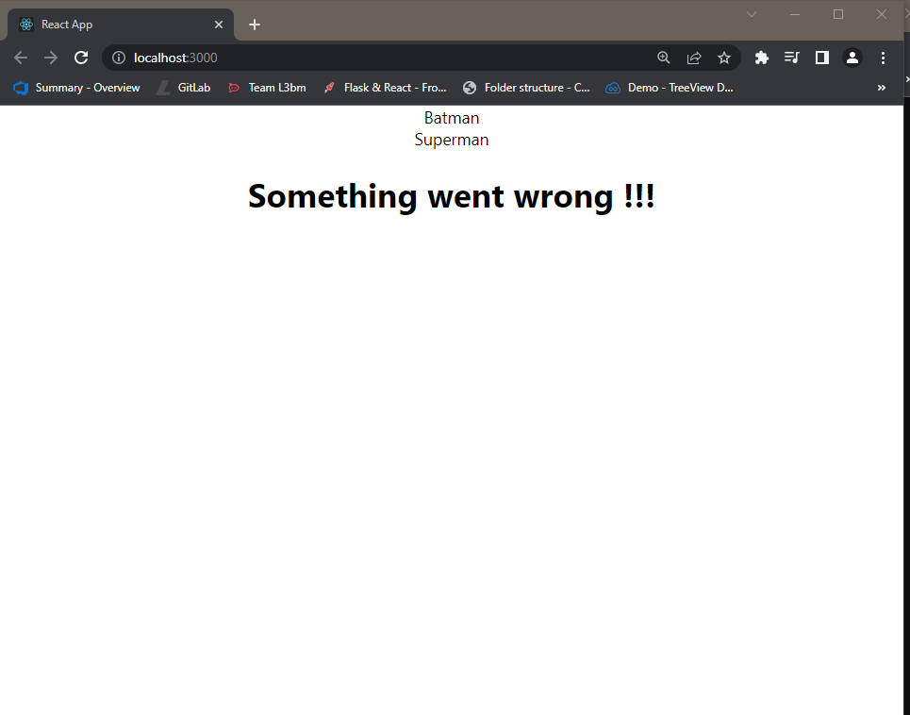

**ComponentDidCatch :**

* ComponentDidCatch accept two parameter error and info
* We can the error using this method ,, by default we can also see the error in console
* import React, { Component } from 'react'
* class ErrorBoundary extends Component {
* constructor(props) {
* super(props)
* this.state = {
* hasError:false
* }
* }
* static getDerivedStateFromError(error){
* return{
* hasError: true
* }
* }
* componentDidCatch(error,info){
* console.log(error)
* console.log(info)
* }
* render() {
* if(this.state.hasError){
* return <h1>Something went wrong !!!</h1>
* }
* return this.props.children
* }
* }
* export default ErrorBoundary

